GULISTAN & TURGUT OZAL EDUCATIONAL INSTITUTIONS
INFORMATICS LESSON PLAN

DATE :
DURATION : | 40 minutes
GRADE LEVEL: | 10th Class
SUBJECT : | Creating Worksheet Charts 1
OBJECTIVES : | To learn how to use Excel Chart

LESSON PLAN
Key words:
Materials used: | Microsoft Excel 2003 Book, Computer
Warm-up questions:

Introduction and explanation of the lesson;

CHARTS
After you process your data, you take outputs. Printing and Charts are the two most common output forms of Excel.
Numbers can definitely present a lot of information, but people get lost in too many numbers. Especially when presenting data to a crowd. People are more interested in visual and graphical
representations and they are much easier to remember. For example, with a graphical chart, as in Figure below, you can see whether your company sales are increasing or decreasing,
without having to analyze any number.

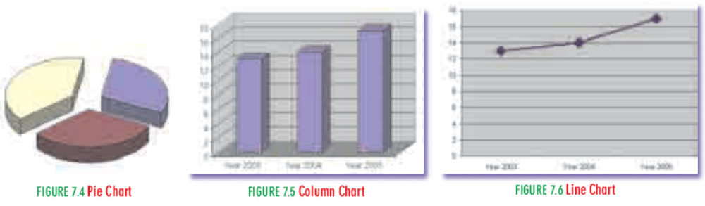

CONCLUSION:

HOMEWORK:

Teacher Director

